# Module-5

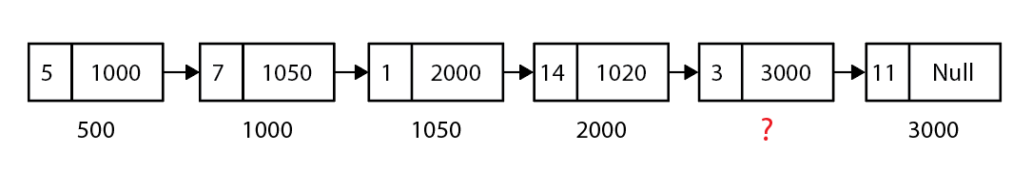

* 1. Why do you think linked-list requires more memory than an array when storing the same number of elements?
  2. Write down Three Limitations of the array which can be solved by the use of Linked List
  3. What is the value of Head?
  4. What is the value of ? marked address location?
  5. What will be the value of Head->Next->Next->Value?
  6. What will be the value of **Sum** following pseudocode snippets?

Sum = 0

Temp = Head

While ( Temp -> Next!= 1020){

Sum += Temp-> value

Temp = Temp -> Next

}

Sum -= Temp -> value;